|  |
| --- |
| Kyushu Institute of Technology  Laboratory of Spacecraft Environment Interaction Engineering |
|  |
| FM Thermal Vacuum Test Procedure |
| BIRDS-4 Project |

|  |  |  |  |
| --- | --- | --- | --- |
| **Date** | **Version Number** | **Writer** | **Annotations** |
| 2019/12/06 | v1.0 | Anibal Mendoza | First Draft |
|  |  |  |  |
|  |  |  |  |
|  |  |  |  |

Contents

1. Introduction 2

1.1. General 2

1.2. Objectives 2

1.3. Scope 2

2. Reference 2

3. Nomenclature 2

3.1. Acronyms 2

3.2. Symbols 3

4. Test Purpose 3

4.1. Overall test purpose 3

4.2. Corresponding Requirements from RAS 3

5. Test Description 3

5.1. Test Place and Time 3

5.1.1. Test Date 3

5.1.2. Test Place 3

5.2. Test Contents 4

5.3. Test Article 4

5.4. Test Flow, Level and Conditions 5

6. Test Facility, Setup and Equipment 6

6.1. Test Facility 6

6.2. Test Setup 7

6.3. Thermal Cycle Profile 7

6.4. Heater positions 8

6.5. Thermocouple positions 8

6.6. Attachment of Thermocouples 10

6.7. Placement of satellite inside the chamber 10

6.8. Equipment and Measuring Instruments 11

7. Test Schedule 11

8. Detailed Test Procedure 12

9. Test Output 14

9.1. Data analysis strategy 14

9.2. Test report 15

9.2.1. Battery heater operation 15

9.2.2. Antenna deployment 15

10. Quality Insurance 15

11. Personnel Assignment 15

12. Safety Requirement 16

12.1. What to say in Japanese 17

# Introduction

## General

The Thermal Vacuum Test (TVT) of the Engineering Model (FM) of BIRDS-4 satellite shall pass qualification requirements under vacuum conditions and temperature extremes which simulate predicted space environment.

## Objectives

The following are the test objectives:

* Check and analyze various satellite point temperatures under extreme hot and cold conditions.
* Check and analyze functionality and operation of the satellite under the defined temperature range (extreme hot, extreme cold and middle temperature conditions).
* Check and analyze operation of battery heater and thermal monitors under the defined temperature range.

## Scope

This document is applied to thermal vacuum test for BIRDS-4 FM using the “Space Chamber” at the Center for Nanosatellite Testing (CeNT) in Kyutech.

# Reference

|  |  |  |
| --- | --- | --- |
| **Document number** | **Document description** | **Revision level or Release date** |
| ISO/TC 20/SC 14 N 1004 | Space systems - Design Qualification and Acceptance Tests of Small-scale  Satellites and Units Seeking Low-cost and Fast-Delivery | 2014/05/05 |
| BIRDS-4 RAS | BIRDS-4 Project Requirement Allocation Sheet | Version 53 (2019/08/01) |

# Nomenclature

## Acronyms

|  |  |
| --- | --- |
| ADCS | Attitude Determination and Control System |
| COM-UHF TRX | UHF transceiver board |
| FM | Flight Model |
| EPS | Electrical Power Subsystem |
| FAB | Front Access Board |
| GPS | Global Positioning System |
| GS | Ground Station |
| LN2 | Liquid Nitrogen |
| MB1-MB2 | Mission Board 1-2 |
| OBC | Onboard Computer |
| PCB | Printed Circuit Board |
| RAB | Rear Access Board |
| RBF | Remove-Before-Flight |
| SP | Solar Panel |
| TC | Thermocouple |
| TVT | Thermal Vacuum Test |

## Symbols

|  |  |
| --- | --- |
| °C | Degree Celsius |
| Ω | Ohm (resistance value) |
| W | Watt |
| Pa | Pascal |

# Test Purpose

## Overall test purpose

* Measure temperatures at different satellite points under extreme hot and cold conditions.
* Check functionality and operation of the satellite under defined temperature range (extreme hot, extreme cold and middle temperature conditions).
* Check operation of battery heater and thermal monitors under defined temperature range.

## Corresponding Requirements from RAS

Table 4.1 Requirements from RAS to be satisfied by the test

|  |  |
| --- | --- |
| **Requirement ID Number**  **(from RAS)** | **Requirement Description** |
| **DR 2.1.1** | Internal allowable BIRDS-4 temperature range shall be -15 to +50 deg Celsius. |
| **DR 2.1.2** | External allowable BIRDS-4 temperature range shall be from -20 to +55 deg Celsius. |
| **DR 3.1.1** | Temperature of the battery shall be monitored. |
| **DR 3.1.2** | Internal boards shall provide temperature data. |
| **DR 3.1.3** | Reaction wheel shall not overrun to limit its temperature. |

# Test Description

## Test Place and Time

### Test Date

The Thermal Vacuum Test will be conducted by the next schedule:

|  |  |  |  |  |  |  |  |  |  |  |
| --- | --- | --- | --- | --- | --- | --- | --- | --- | --- | --- |
| From: | | |  | To: | | |  | Total of | _____ | day(s). |
| **YY** | **MM** | **DD** |  | **YY** | **MM** | **DD** |  |

This schedule includes setup preparation, the actual test cycles (with satellite functional test) and setup recovery.

### Test Place

Center for Nanosatellite Testing, Laboratory of Spacecraft Environment Interaction Engineering, Kyushu Institute of technology, 1-1 Sensui, Tobata, Kitakyushu, 804-8550 Fukuoka, Japan.

## Test Contents

The test shall consist of:

1. Preparation of the satellite, thermocouples (TCs), connectors, GS setup and other materials to be used for the test
2. Attachment of TCs to the satellite and checking the response
3. Satellite assembly and checking of satellite functionality in normal laboratory setup (in BIRDS Room condition).
4. Installation of the satellite, TCs, and connectors inside the vacuum chamber and checking connectivity and responses
5. Checking the satellite functionality inside the vacuum chamber before closing (atmospheric condition)
6. Vacuuming
7. Measurement of temperature of various satellite points in vacuum condition during the thermal vacuum test (especially at extreme cold condition, extreme hot condition and during the temperature transition)
8. Checking the satellite functionality during the thermal vacuum test (especially at extreme cold condition, extreme hot condition and during the temperature transition)
9. Checking battery heater operation during the thermal vacuum test
10. Setup recovery and removing the satellite from the vacuum chamber

## Test Article

The test article description is shown in Table 2

Table 5.1 Test article description

|  |  |  |  |
| --- | --- | --- | --- |
| **No.** | **Article name** | **Quantity** | **Manufacturer** |
| 1 | BIRDS-4 FM | 3 | - |

The FM 3D model is shown in Figure 1

|  |
| --- |
|  |
|  |

Figure 1 BIRDS-4 FM 3D model

## Test Flow, Level and Conditions

The chamber pressure must be kept below $1*{10}^{-4} [Pa]$ during all conditions of the thermal vacuum test. In this pressure range, heat exchange by molecular flow is negligible. Table 3 summarizes originally planned and reached temperature range and number of cycles of the test. After experimenting with the first cycle, a target of -15ºC and +30 °C are taken as control temperatures for internal boards.

Table 5.2 Temperature range for internal boards and number of cycles

|  |  |  |
| --- | --- | --- |
|  | Originally Planned | Reached |
| Worst cold | $$-15 °C$$ |  |
| Worst hot | $$+30 °C$$ |  |
| Number of cycles | $$4$$ |  |

# Test Facility, Setup and Equipment

## Test Facility

Specifications of the thermal vacuum chamber are given in Table 4.

Table 6.1 Vacuum chamber specification

|  |  |  |
| --- | --- | --- |
| **No.** | **Items** | **Specification** |
| 1 | Name | Thermal vacuum test equipment (Space Chamber) |
| 2 | Size | L1700 x L1500 mm (shroud inner diameter) |
| 3 | Material | Stainless steel |
| 4 | Ultimate Vacuum | $$5.0*{10}^{-6} \left[Pa\right]$$ |
| 5 | Shroud Temperature | |
| 6 | Size of test table | W 500 x D 500 x H 500 mm. 50 kg |
| 7 | Characteristics | Satellite rail + gauge  Clean booth  Power output: 400 W x6  Heat input current introduction terminal 32  Signal terminal: BNC x3 SMA x2  Thermocouple: Type K x80  Relay AC x3 DC x3 |

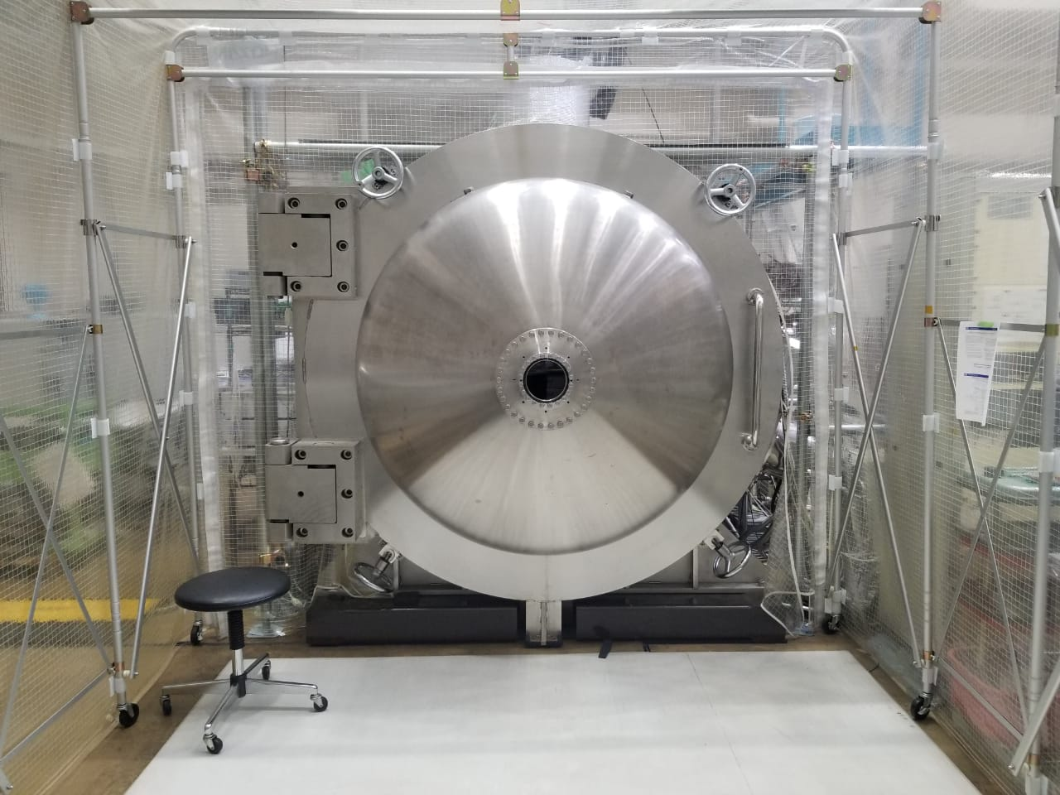

Figure 2 Space Chamber at CeNT

## Test Setup

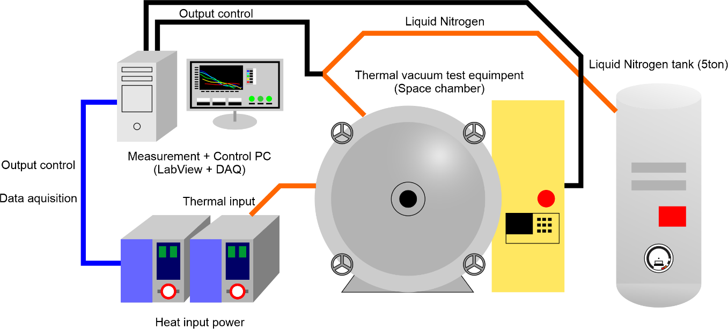

Figure 3 Overall test setup



Figure 4 Connections from COM-UHF transceiver boards to the GS equipment

## Thermal Cycle Profile

* The test is planned to be conducted for 4 cycles (4 cold and 4 hot) as shown in Figure 5.
* At the extreme cold temperature and at the extreme hot temperature of each cycle, soaking time would be two hours with one hour for functional testing. However, this was not the case while testing. The soak lasted at least half an hour with about another half an hour for functional testing.
* There were total 10 temperature measurement points for the satellite, including the six on the external panel points.
* The monitoring/control temperature was average of six external panels.
* The worst hot condition for the external panel is +30°C.
* The battery heater of the satellite thermal subsystem would be activated at 8°C and less.
* The battery temperature was controlled to go close to 0°C. However, in real case, the battery temperature went below 0°C during functional testing.

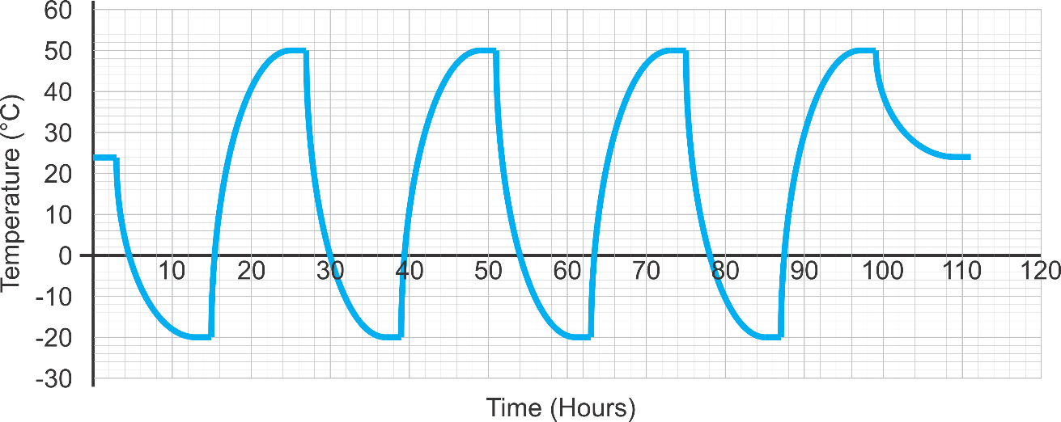

Figure 5 Planned thermal cycle profile

## Heater positions

The following table provides the sheet heater parameters such as position, size, resistance and maximum power that can be used for the test.

Table 6.2 Heater properties

|  |  |  |  |  |  |
| --- | --- | --- | --- | --- | --- |
| Heater Number | Position | Size | Resistance | Total Resistance | Power supply number |
|  |  |  |  |  |  |
|  |  |  |  |  |  |
|  |  |  |  |  |  |
|  |  |  |  |  |  |
|  |  |  |  |  |  |
|  |  |  |  |  |  |
|  |  |  |  |  |  |

Figure 6 Inside chamber configuration schematic

## Thermocouple positions

The thermocouple positions are summarized in the following table.

Table 6.3 Positions of the thermocouples

|  |  |  |  |
| --- | --- | --- | --- |
| TC No. | Position | TC name in PC | Measurement point |
| 1 | PY_Battery Box (outside) | Bat_Box | Refer to Table 6 |
| 2 | PY_Reaction Wheel Assembly | Reaction_Wheel |
| 3 | PY_+X External Panel | Pos_X_Panel |
| 4 | PY_-X External Panel | Neg_X_Panel |
| 5 | PY_+Y External Panel | Pos_Y_Panel |
| 6 | PY_-Y External Panel | Neg_Y_Panel |
| 7 | PY_+Z External Panel | Pos_Z_Panel |
| 8 | PY_-Z External Panel | Neg_Z_Panel |
| 9 | PH_Battery Box (outside) | Bat_Box |
| 10 | PH_Reaction Wheel Assembly | Reaction_Wheel |
| 11 | PH_+X External Panel | Pos_X_Panel |
| 12 | PH_-X External Panel | Neg_X_Panel |
| 13 | PH_+Y External Panel | Pos_Y_Panel |
| 14 | PH_-Y External Panel | Neg_Y_Panel |
| 15 | PH_+Z External Panel | Pos_Z_Panel |
| 16 | PH_-Z External Panel | Neg_Z_Panel |
| 17 | JP_Battery Box (outside) | Bat_Box |
| 18 | JP_Reaction Wheel Assembly | Reaction_Wheel |
| 19 | JP_+X External Panel | Pos_X_Panel |
| 20 | JP_-X External Panel | Neg_X_Panel |
| 21 | JP_+Y External Panel | Pos_Y_Panel |
| 22 | JP_-Y External Panel | Neg_Y_Panel |
| 23 | JP_+Z External Panel | Pos_Z_Panel |
| 24 | JP_-Z External Panel | Neg_Z_Panel |
| 25 | Cylinder Shroud |  |  |
| 26 | Front wall |  |  |
| 27 | Back wall |  |  |
| 28 | Heater1 |  |  |
| 29 | Heater2 |  |  |
| 30 | Heater3 |  |  |
| 31 | Heater4 |  |  |
| 32 | Heater5 |  |  |
| 33 | Heater6 |  |  |

Table 6.4 Measurement Points

|  |  |  |  |
| --- | --- | --- | --- |
| **External Panels** | | | |
|  |  | |  |
| +Z External Panel | +Y External Panel | | +X External Panel |
|  |  | |  |
| -Z External Panel | -Y External Panel | | -X External Panel |
| **Internal Components** | | | |
| Y axis Magnetic Coil | | Z axis Magnetic Coil | |
|  | |  | |
| Battery Box | | Reaction Wheel Assembly | |

## Attachment of Thermocouples

The next figure shows the steps of attaching the thermocouples to satellite surfaces and components.

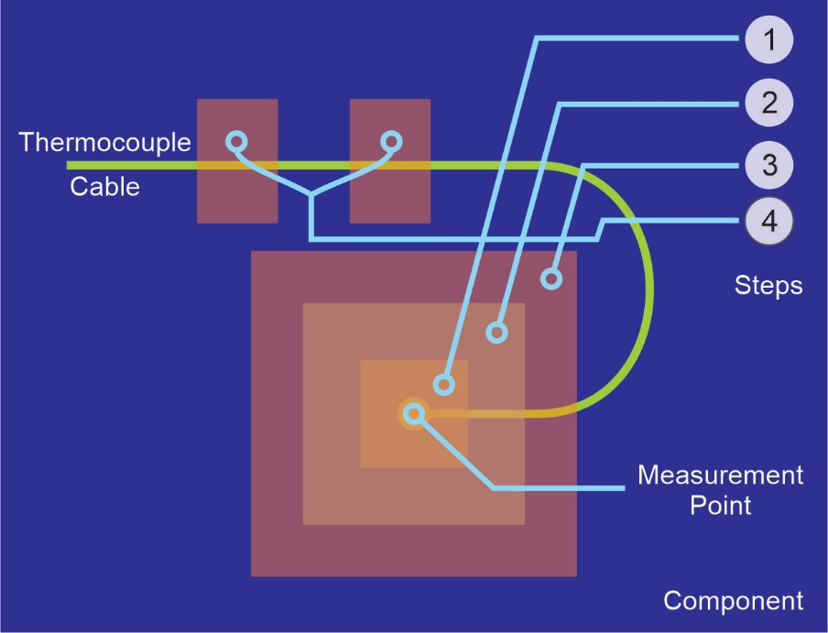

Figure 7 Thermocouple attachment

* Step 1: Cover thermocouple tips by a small piece of polyimide tape
* Step 2: Fix the thermocouple terminal using aluminum tape
* Step 3: Cover the aluminum tape by polyimide tape
* Step 4: Fix the thermocouple wire by polyimide tapes

## Placement of satellite inside the chamber

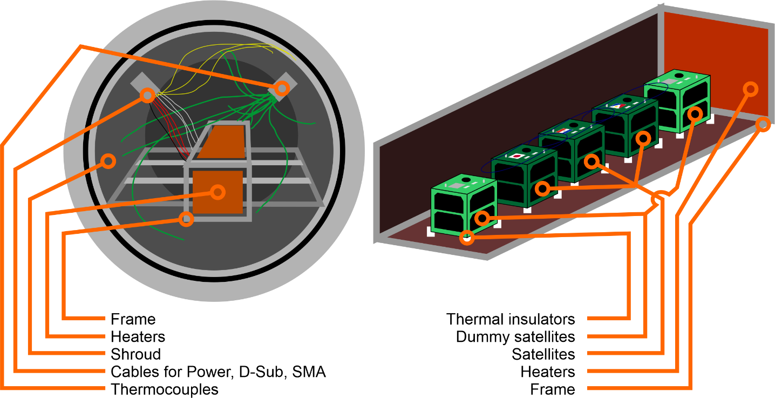

Figure 8 Placement of Satellite inside the chamber

## Equipment and Measuring Instruments

Table 6.5 Equipment and measuring instruments details

|  |  |  |  |  |
| --- | --- | --- | --- | --- |
| **No** | **Equipment** | **Quantity** | **Model** | **Comments** |
| 1 | Thermocouple | 33 | Type-K | -180 to +1300 °C |
| 2 | Data Acquisition PC | 1 | N/A | For chamber control |
| 3 | DAQ-mx | 2 | NI 9213 | 24-bit ADC |
| 4 | Power Supplies | 2 |  | 0-320V |
| 5 | Transceiver | 1 | IC-9100 | For functional test |
| 6 | Attenuator | 3 |  | For functional test |
| 7 | Functional Test PC | 2 | N/A | For functional test |
| 8 | Terminal Node Controller | 1 | KPC-9612+ | For functional test |
| 9 | Sheet heaters |  |  |  |

# Test Schedule

The test schedule is shown in Table 8 below, the schedule is tentative and can be changed base on the actual test conditions.

Table 7.1 Test schedule

|  |  |  |  |  |  |  |  |  |  |  |  |  |  |  |  |  |  |  |
| --- | --- | --- | --- | --- | --- | --- | --- | --- | --- | --- | --- | --- | --- | --- | --- | --- | --- | --- |
| PROCEDURE | MM | DD | MM | DD | MM | DD | MM | DD | MM | DD | MM | DD | MM | DD | MM | DD | MM | DD |
| AM | | PM | | AM | | PM | | AM | | PM | | AM | | PM | | AM | |
| Preparation of the satellite, thermocouples (TCs), sheet heaters, connectors, GS setup and other materials to be used for the test |  | |  | |  | |  | |  | |  | |  | |  | |  | |
| Attachment of TCs to the satellite and checking the response |  | |  | |  | |  | |  | |  | |  | |  | |  | |
| Satellite assembly and checking of satellite functionality in normal laboratory setup (in Room condition)  Installation of the satellite, TCs, and connectors inside the vacuum chamber and checking connectivity and responses |  | |  | |  | |  | |  | |  | |  | |  | |  | |
| Checking the satellite functionality inside the vacuum chamber before closing (atmospheric condition) |  | |  | |  | |  | |  | |  | |  | |  | |  | |
| Vacuuming |  | |  | |  | |  | |  | |  | |  | |  | |  | |
| Inject LN2 |  | |  | |  | |  | |  | |  | |  | |  | |  | |
| Thermal Cycle |  | |  | |  | |  | |  | |  | |  | |  | |  | |
| De-vacuuming, setup recovery and removing the satellite from the vacuum chamber |  | |  | |  | |  | |  | |  | |  | |  | |  | |

# Detailed Test Procedure

The detail test procedures shown in Table 9 with tasks need to be done before, during and after the test, the person in charge of each task should check the task once it is finished.

|  |  |  |
| --- | --- | --- |
| Verification | | |
| Preparation and checking the satellite and chamber | | |
| (Cold Cycle) | Make vacuum and conduct the thermal test and functional test | (Hot Cycle) |
| Stop the test, clean up and check the satellite | | |

Table 8.1 Detailed test procedure

|  |  |  |  |  |  |  |
| --- | --- | --- | --- | --- | --- | --- |
| **No** | **Procedure** | **Check** | **Date** | **Time** | **Responsible** | **Comments** |
| 1 | Verify all satellite functionalities and operation (preliminary, in BIRDS Room) |  | 0000/00/00 | 00:00 |  |  |
| 2 | Prepare and check thermocouples |  |  |  |  |  |
| 3 | Check chamber's thermocouple connections |  |  |  |  |  |
| 4 | Check chamber's D-Sub and RF port connections |  |  |  |  |  |
| 5 | Disassemble structure and center box |  |  |  |  |  |
| 6 | Attach thermocouples to Satellite |  |  |  |  |  |
| 7 | Take photos and note the TCs’ positions |  |  |  |  |  |
| 8 | Reassemble satellite and check thermocouples and heaters connection |  |  |  |  |  |
| 9 | Check satellite functionalities |  |  |  |  |  |
| 10 | Move satellite to the chamber |  |  |  |  |  |
| 11 | Install the satellite in the chamber |  |  |  |  |  |
| 12 | Check again all heaters’ and TCs’ response on the PC |  |  |  |  |  |
| 13 | Check satellite functionalities |  |  |  |  |  |
| 14 | Chamber closing, start of rough vacuum |  |  |  |  |  |
| 15 | Finish rough vacuum |  |  |  |  |  |
| 16 | Start high vacuum |  |  |  |  |  |
| 17 | High vacuum reached |  |  |  |  |  |
| 18 | Start Functional test |  |  |  |  |  |
| 19 | Finish Functional test |  |  |  |  |  |
| 20 | Inject LN2 |  |  |  |  |  |
| 21 | Start cold ramp #1C |  |  |  |  |  |
| 22 | Temp stabilization reached (cold) #1C |  |  |  |  |  |
| 23 | Start Functional test #1C |  |  |  |  |  |
| 24 | Finish Functional test #1C |  |  |  |  |  |
| 25 | Start hot ramp #1C |  |  |  |  |  |
| 26 | Temp stabilization reached (hot) #1C |  |  |  |  |  |
| 27 | Start Functional test #1C |  |  |  |  |  |
| 28 | Finish Functional test #1C |  |  |  |  |  |
| 29 | Start cold ramp #2C |  |  |  |  |  |
| 30 | Temp stabilization reached (cold) #2C |  |  |  |  |  |
| 31 | Start Functional test #2C |  |  |  |  |  |
| 32 | Finish Functional test #2C |  |  |  |  |  |
| 33 | Start hot ramp #2C |  |  |  |  |  |
| 34 | Temp stabilization reached (hot) #2C |  |  |  |  |  |
| 35 | Start Functional test #2C |  |  |  |  |  |
| 36 | Finish Functional test #2C |  |  |  |  |  |
| 37 | Start cold ramp #3C |  |  |  |  |  |
| 38 | Temp stabilization reached (cold) #3C |  |  |  |  |  |
| 39 | Start Functional test #3C |  |  |  |  |  |
| 40 | Finish Functional test #3C |  |  |  |  |  |
| 41 | Start hot ramp #3C |  |  |  |  |  |
| 42 | Temp stabilization reached (hot) #3C |  |  |  |  |  |
| 43 | Start Functional test #3C |  |  |  |  |  |
| 44 | Finish Functional test #3C |  |  |  |  |  |
| 45 | Start cold ramp #4C |  |  |  |  |  |
| 46 | Temp stabilization reached (cold) #4C |  |  |  |  |  |
| 47 | Start Functional test #4C |  |  |  |  |  |
| 48 | Finish Functional test #4C |  |  |  |  |  |
| 49 | Start hot ramp #4C |  |  |  |  |  |
| 50 | Temp stabilization reached (hot) #4C |  |  |  |  |  |
| 51 | Start Functional test #4C |  |  |  |  |  |
| 52 | Finish Functional test #4C |  |  |  |  |  |
| 53 | Stop LN2 injection |  |  |  |  |  |
| 54 | Get to room temperature |  |  |  |  | Turn on chamber heater to increase chamber temperature |
| 55 | Room temperature reached |  |  |  |  |  |
| 56 | Start Functional test |  |  |  |  |  |
| 57 | Finish functional test |  |  |  |  |  |
| 58 | De-vacuuming and recovery |  |  |  |  |  |
| 59 | Do fit check with satellite |  |  |  |  |  |
| 60 | Remove TCs |  |  |  |  |  |

# Test Output

## Data analysis strategy

Table 10 below show the operating temperature range for the satellite. The temperature of each component during the test should be inside of operating temperature range.

Table 9.1 Components operating temperature range

|  |  |  |  |  |
| --- | --- | --- | --- | --- |
| Component | Operating Temperature Range (°C) | | Recorded Temperature Range during Test (°C) | |
| Lowest | Highest | Lowest | Highest |
| Battery Box Assembly | 0 | +40 |  |  |
| Front Access Board | -40 | +80 |  |  |
| On Board Computer | -40 | +85 |  |  |
| Communication Board | -20 | +60 |  |  |
| Mission Board 1 | -40 | +85 |  |  |
| Mission Board 2 | -20 | +70 |  |  |
| Rear Access Board | -40 | +80 |  |  |
| Back Plane Board | -40 | +105 |  |  |
| X axis MTQ |  |  |  |  |
| Y axis MTQ |  |  |  |  |
| Z axis MTQ |  |  |  |  |
| Reaction Wheel |  |  |  |  |
| Plus X Panel | -40 | +85 |  |  |
| Minus X Panel | -40 | +85 |  |  |
| Plus Y Panel | -40 | +85 |  |  |
| Minus Y Panel | -40 | +85 |  |  |
| Plus Z Panel | -40 | +85 |  |  |
| Minus Z Panel | -40 | +85 |  |  |

## Test report

The following data shall be provided in the test report after the testing is completed:

* Temperature profile of all measurement points during the test.\
* Results on functionality tests
* Evaluation of the test results
* Battery heater operation status
* RW temperature sensor check
* Antenna deployment functions check

# Quality Insurance

Temperature [˚C]: 20 ± 5

Humidity [%]: 70 ± 10

Chamber Pressure: 10-5 Pa

# Personnel Assignment

Table 11 show the personnel assignment for the thermal vacuum test.

Table 11.1 Personnel Assignment During Setup Preparation

|  |  |
| --- | --- |
| **Task** | **Responsible Person** |
| Ground Station Equipment |  |
| Preparation and installation of heaters and thermocouples |  |
| D-sub Connector Preparation |  |
| Battery Charging Setup |  |
| Antenna preparation and deployment test trial |  |
| Documentation |  |
| Support |  |
| TVT lead |  |
| Team management |  |

# Safety Requirement

During the test period, in consideration of the safety of work, strictly observe the following matters:

1. During testing, the field officer shall supervise all work and instruct properly to assure the safety of work.
2. Use a crane or a handcart to move any heavy item with anticipated risk.
3. The ceiling crane shall be operated only by licensed personnel. I-bolt / lifting equipment should be inspected each time before operating the crane. No entry to the area under the suspended material is permitted.
4. During testing, keep unnecessary items away from the testing machine.
5. Gloves shall be worn when handling a satellite or sensors.
6. Do not place any item on safety-related motion lines, such as the emergency exit, corridor, fire extinguishers, etc.
7. When a high voltage apparatus is used, turn off the power before inspecting, touching, or modifying, etc.
8. In the case of a natural disaster or a serious accident, take emergency measures and prevent secondary accidents immediately. Then communicate via the following emergency communication links shown below in Figure 9.

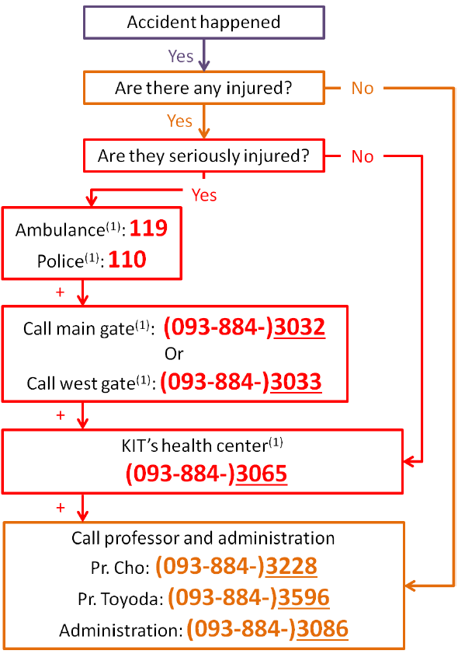

Figure 9 Emergency procedure flow chart

## What to say in Japanese

1. You are the center, 4th floor

Kyushu kogyo daigaku, kogakubu no sogo kenkyu ichi-goto, yonkai de ________nin fushosha (= injured)/kasai (= fire) ga hassei shimasita. Watashi ha ________ (your name) desu.

Kyushu Institute of Technology, General Research Building No. 1, 4th floor. There are ________ people injured/There is a fire. I am ________ (your name).

1. You are at SVBL, 1st floor

Kyushu kogyo daigaku, kogakubu no sogo kenkyu ni-goto, ichikai de ________nin fushosha (= injured)/kasai (= fire) ga hassei shimasita. Watashi ha ________ (your name) desu.

Kyushu Institute of Technology, General Research Building No. 2, 1st floor. There are ________ people injured/There is a fire. I am ________ (your name).

1. You are at SVBL, 2nd floor

Kyushu kogyo daigaku, kogakubu no sogo kenkyu ni-goto, nikai de ________nin fushosha (= injured)/kasai (= fire) ga hassei shimasita. Watashi ha ________ (your name) desu.

Kyushu Institute of Technology, General Research Building No. 2, 2nd floor. There are ________ people injured/There is a fire. I am ________ (your name).

1. You are at SVBL, 3rd floor

Kyushu kogyo daigaku, kogakubu no sogo kenkyu ni-goto, sankai de ________nin fushosha (= injured)/kasai (= fire) ga hassei shimasita. Watashi ha ________ (your name) desu.

Kyushu Institute of Technology, General Research Building No. 2, 3rd floor. There are ________ people injured/There is a fire. I am ________ (your name).